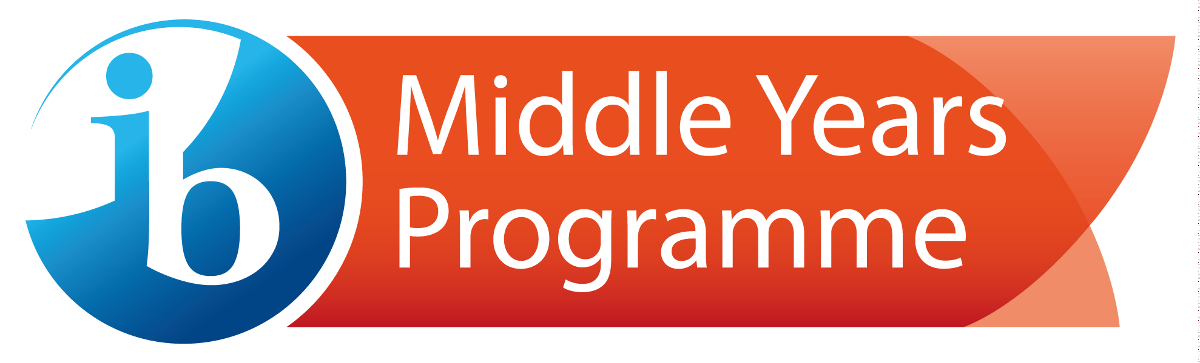

Start-Up Cost Estimate – Middle Years Programme (MYP): Partner School/Schools
Year of consideration | Application fee* (and required Professional Development (PD) for the Head of School) | Free  (+$450-$1600 for initial PD) | Copy of check, or purchase order and workshop completion certificate are uploaded into documents section of the application for candidacy.
Year 1 | Candidacy and consultation services Y1 fee  Includes remote consultation, 2-day on-site visit, consultant visit report, end of consultancy report, access to the IB's Programme resource centre, direct support from the authorization department via Programme Relationship Manager | $950* | Once a school has been awarded candidacy, a non-refundable candidacy and consultation services fee will be charged to the school on the 1st of the month following the granting of their candidacy.
One MYP subject area training per discipline is sufficient for authorization, per campus.  See p.12-13 of Guide to school authorization: Middle Years Programme | Training Costs per participant  Option 1: Online - approx. $450  Option 2: Face-to-face - starting at $744 (Travel and accommodation are additional expenses)  Other Options: Refer to PD Offerings PDF and/or https://www.ibo.org/professional-development/find-events-and-workshops/  NOTE: Some schools choose to spread training costs across both years of candidacy. Training requirements must be met for authorization.  Developing the MYP workshop  On-site training - $3,000 per 50 participants  Online 1-day training - 1 week. $75 per participant (up to 50 participants) and $60 per participant (51+ participants)  Other Options: Refer to PD Offerings PDF and/or https://www.ibo.org/professional-development/find-events-and-workshops/
Year 2 | Candidacy and application for authorization services Y2 fee  Candidacy and consultation services fee will no longer be charged. This service fee will be billed yearly from this point until the school is authorized: covers cost of assessing and processing the application for authorization, a 2 day verification visit to the school (only one visit per candidacy is covered), a verification visit report, final authorization of the school, access to the IB's Programme resource centre, direct support from the authorization department via your Programme Relationship Manager. | $950* | Once a school notifies the IB that it would like to apply for authorization, a non-refundable candidacy and application for authorization services fee will be charged to the school on the 1st of the month following this request.
Year 3 | Annual school fee (Post authorization) | $1050* | Invoiced in June with July 1 deadline
Year 5 | MYP Building Quality Curriculum (BQC) offers guidance and feedback on MYP unit plans. The cost estimate represents a full submission from the school – two unit plans per eight subject groups plus two interdisciplinary units: 18 submissions in total. Important note: Participation in MYP BQC is required for schools that do not register at least one student for eAssessment, who is a candidate for the IB MYP certificate. | $2,268*
Year 8 | Evaluation visit (Every 5 years), there are scaled fees for synchronized and multi-programme evaluation visits based on the number of combined programs. Speak with your IBWS manager for more details | $4000*

Summary of Estimated Start-up Costs for MYP per school
from Application to First Year of Authorization

Fees: Application (waived for MYP Partner schools), Candidacy & Consultation Services (10% of MYP fee per year), Candidacy & Application for Authorization Services (10% of MYP fee per year), ‘Developing’ workshop fee, Annual school fee (10% of MYP Annual School Fee), Evaluation visit

Minimum Training Costs: Head of School + MYP Coordinator + 8 Subjects + Developing the MYP
PLEASE NOTE: Head of School must be registered for training or trained before application can be submitted.

Additional costs for consideration:
- IB Coordinator release time to oversee the programme
- School provided ground transportation (from hotel to the school and back) and lunch on the workshop day
- Student fees for eAssessments or Building Quality Curriculum service for guidance and feedback on MYP unit plans

*All fees on this document are in $USD and are subject to change.
Please refer to the School Guide to Authorization for requirement details. This document is to be used as a guide. The IB is not responsible for budgetary items unaccounted for beyond the information provided to outline core fees related to application, candidacy, professional development and authorization.

